Quantification of SrTiO3 O/Ti ratio with model based quantification: a step by step guide

Experimental details
The spectra are recorded with the following experimental parameters:
- operator Jo Verbeeck
- Philips CM30, University of Antwerp, EMAT
- 300kV
- dispersion 0.3eV
- energy resolution FEG ~1eV
- diffraction mode EELS
- indicated cam length=50mm
- GIF entrance aperture=2mm
- collection angle 2.675 mrad (calibrated from diff pattern)
- convergence angle 0.9 mrad (for LL slightly larger)
- effective collection angle 2.8 mrad
- reduced intensity of LL with selected area aperture and spread beam
- some carbon contamination possible (don`t trust start of background)

Load the experimental spectra
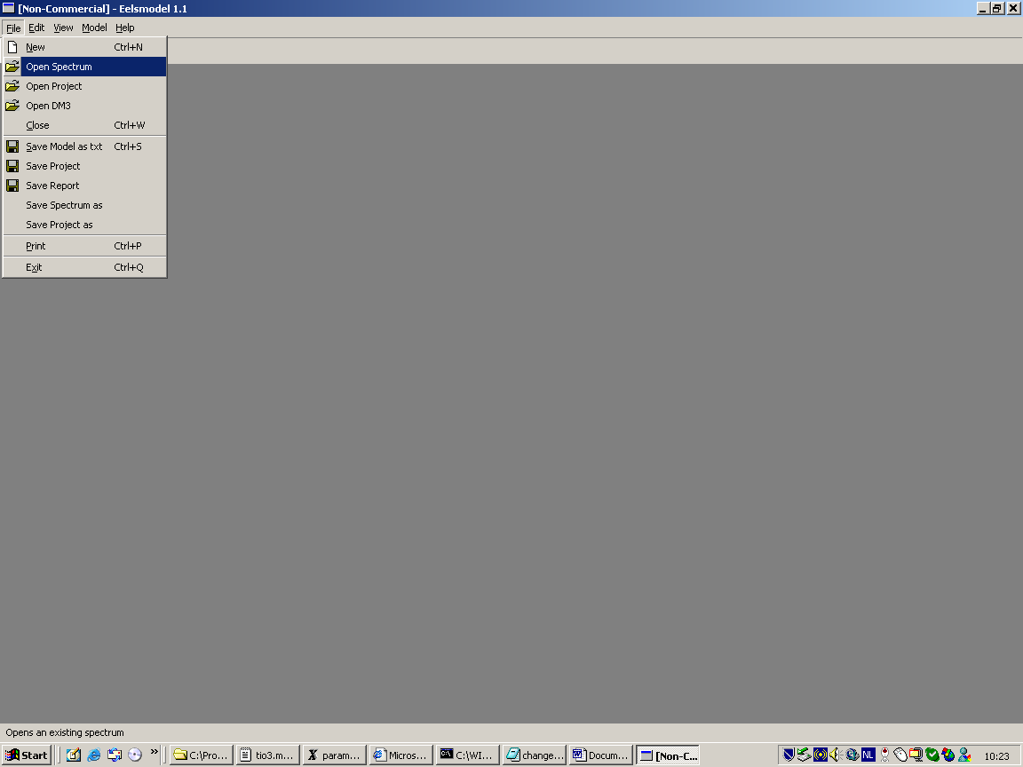
load
hl.msa
ll.msa
Note: you can alternatively load 2D SI spectra by choosing [load DM3], be careful however only SI spectra with one spatial dimension and one spectral dimension are suported.

Create a model
select the core loss spectrum and select [model]_[create new model]
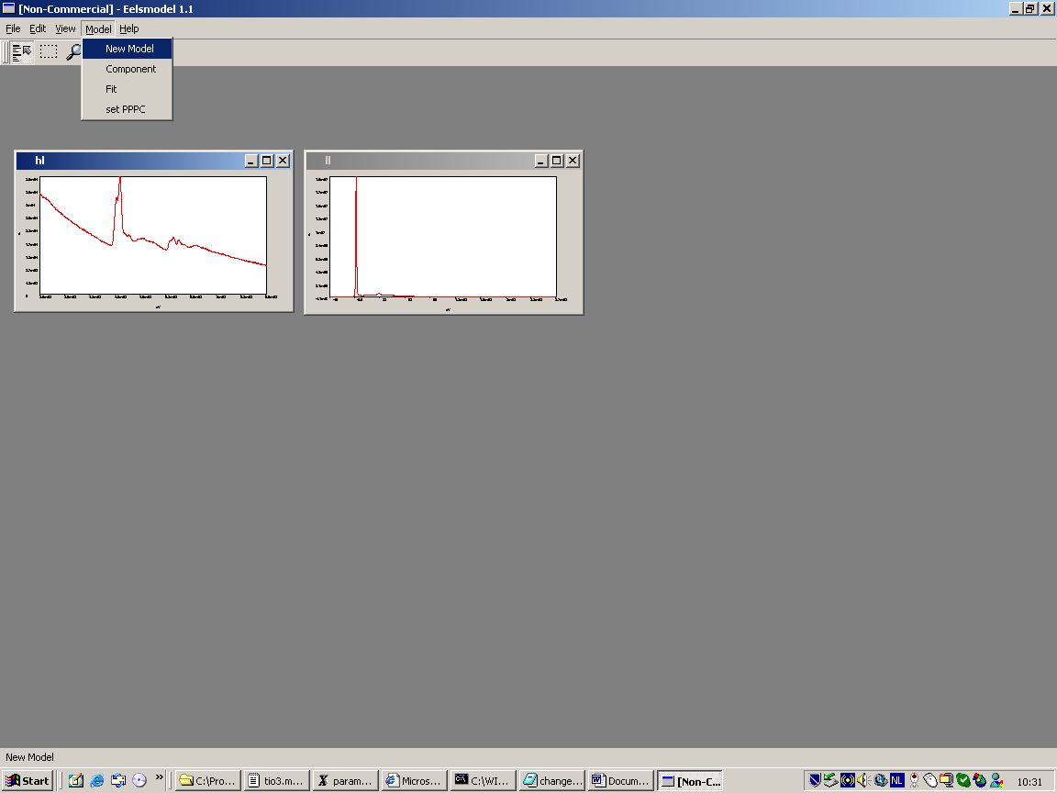
this creates an empty model
important step: set the PPPC value for the microscope. This value is important to estimate the amount of noise in a spectrum. The spectrum is converted from digital counts to detected electrons. For more detailed information see [1]
for the microscope used (CM30 with GIF2000 1k camera) pppc=0.89
note: it is important to do this step now, because this will change the values in the spectrum, if you do it later you will have to change all your parameters by hand.
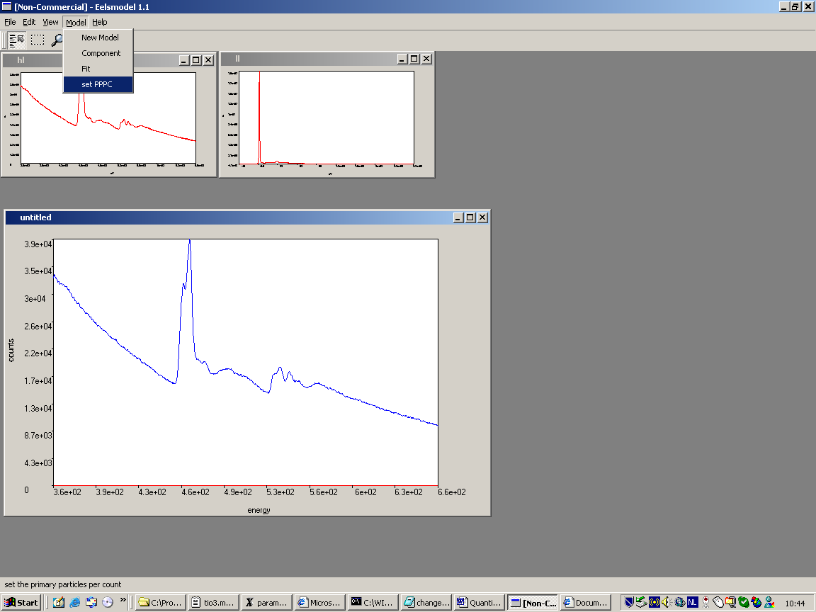

Adding components to the model
Select [model] [component]. This will pop up a list with available components along with the current components in the model.
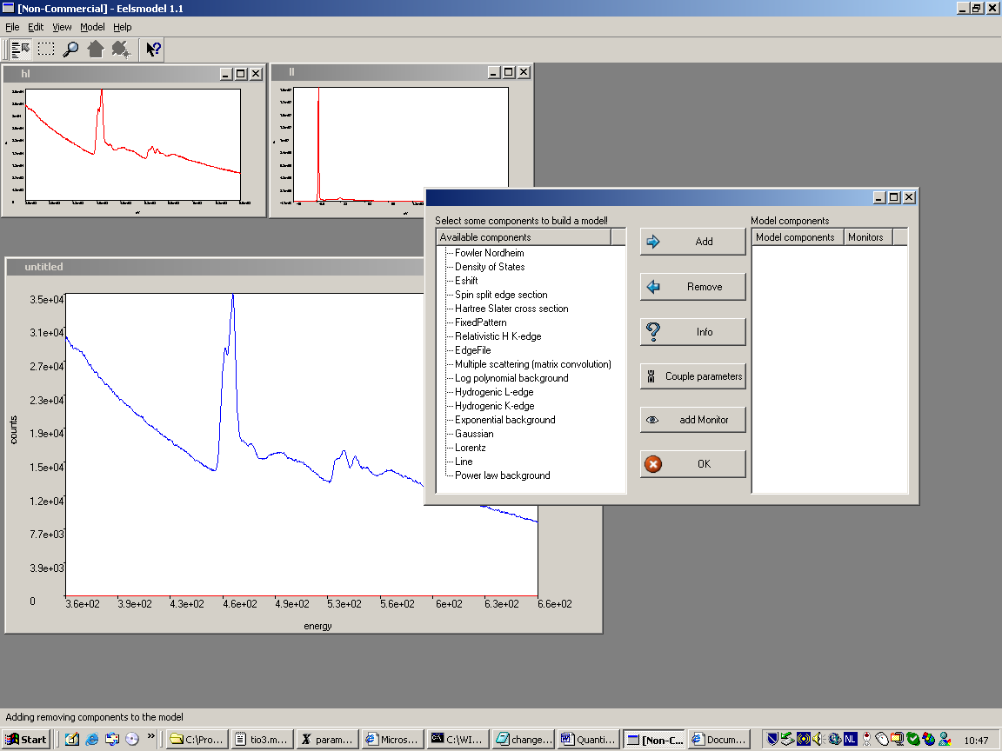
now we can start adding components to our empty model

Background
we start with a power law background (alternatively we could use a log polynomial background which is more difficult to set up because of the sensitivity with respect to the parameters)
select power law background in the [available component] list and click the [add] button (to get info on a component you can press the [info] button)
This pops up a window to enter the A parameter of the AE^{-r} power law function
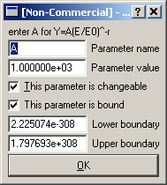
Several parameters can be set here:
First of all we need to enter a guess for the A parameter. Because of the scaling with E/E0, the A parameter signifies the height of the spectrum at the spectrum onset. From the spectrum we read that this is approximately 3e4.
The parameter is changeable: keep it this way otherwise the value you type will not affect the parameter because it is locked.
The parameter is bound: this means there is an upper and a lower bound on the parameter. By default this is the smallest and largest value this parameter can take. It is advisable to limit the boundaries somehow to avoid problems when fitting diverges. A good option here would be to take [0,1e6] as limits, this forces A to be positive as it should be.
Note: be careful, give parameters enough 'freedom'. If a parameter is close to 0 then setting the limit to 0 is not a good idea because it will prevent the fitting process to really reach 0. A good option in the case would be e.g. setting the lower limit to -0.1. Anyway, if the fitter seems to have problems reaching an obvious minimum, then try to set your boundaries less restrictive. Always check for parameters that come very close to boundaries as this is a sign that your boundaries are preventing the fitter to go where it wants...
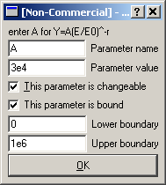
next we set up the r parameter as 3 with boundaries [1,10] as usual for r parameter in an EELS spectrum.
This completes the initialisation of the power law component and shows the model in red in the model window.
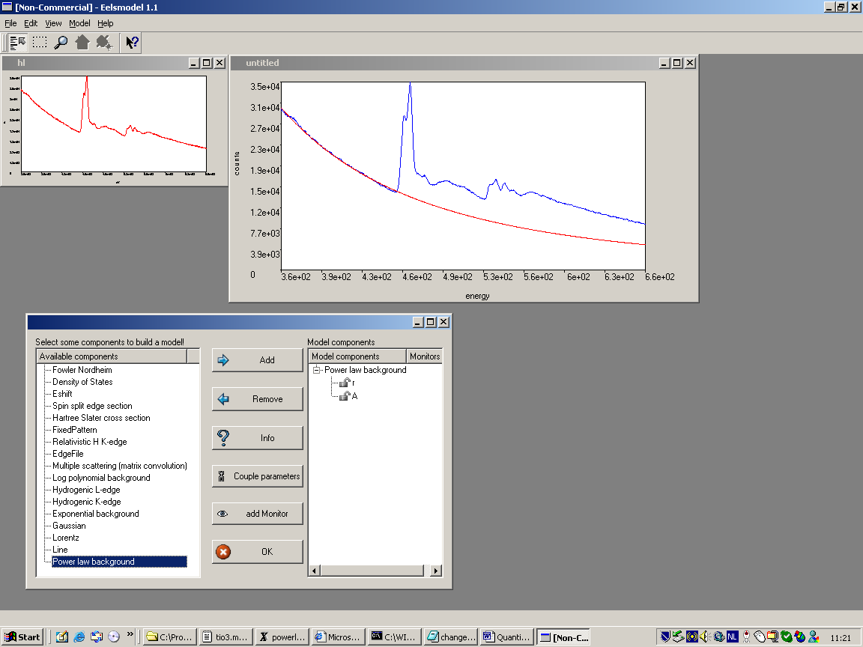

Ti L2,3-edge
We choose a Hartree Slater model (alternatively you can use a hydrogenic model) by adding a [hartree slater cross section] .
We set the following parameters some reasonable boundaries:
- E0=300e3 [kV] [no boundaries, this value will be fixed]
- Ek=455 [eV] [450,460]
- select a HS GOS file: this can be found under \program files\gatan\digital micrograph\HS-GOS tables\ti.l3 (if you have digital micrograph, otherwise use hydrogenic cross sections)
- thetasteps=100 (the number of integration steps in the angular integral, 100 is usually a good value, choose higher if the calculated cross sections looks noisy, but this will take more computing time)
- thetamax=2.8e-3 [rad] this is the effective collection angle (beta_eff=sqrt(alfa^2+beta^2), this is an all-important value to get from the experiment)
- strength=100 (at this time we don't know yet what the strength should be)
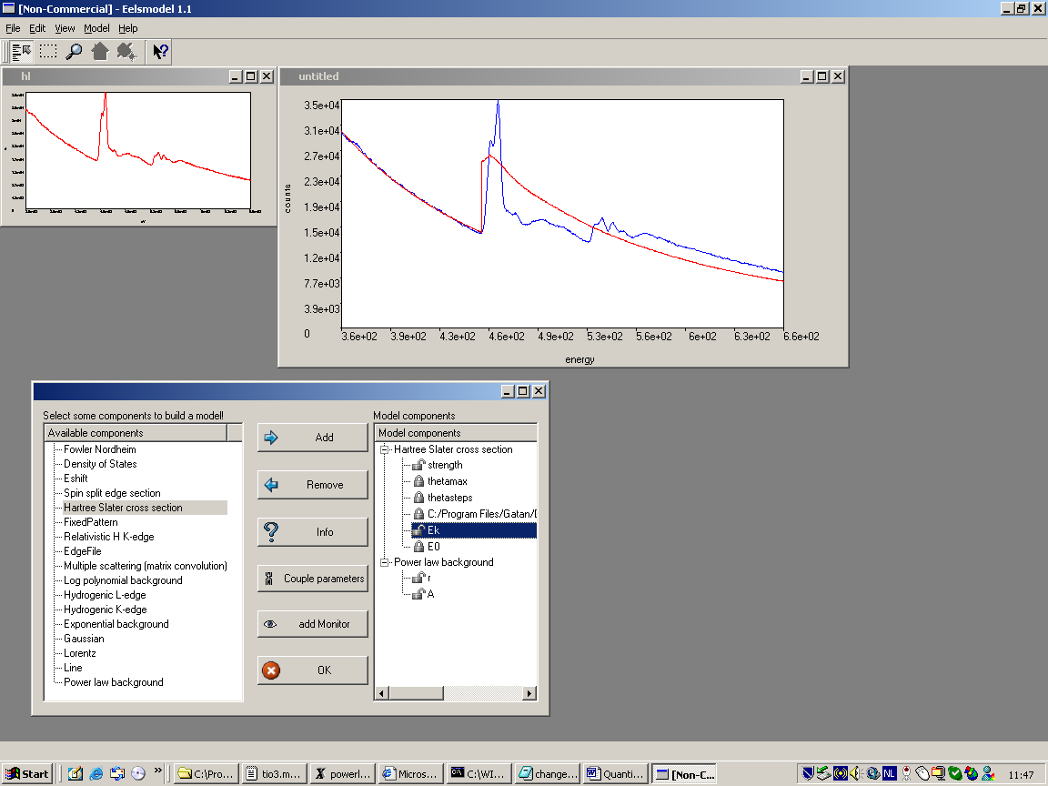
When the component is completed we see it drawn in the model. We see that the cross sections is too high, we can double click on the parameter to change the strength.
We update the strength to 60 and set the boundaries to [0,1e3]
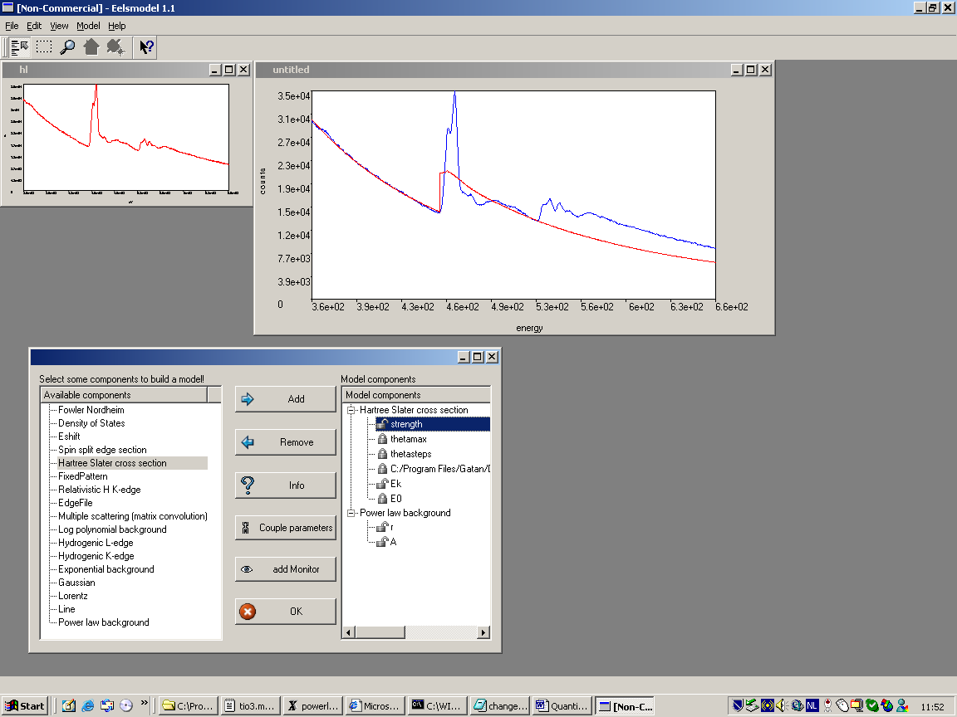
which improves the fit with experiment.

O K-edge
now add the O K-edge as a [hartree slater cross section] with parameters:
- E0=300e3 [kV] [no boundaries, this value will be fixed]
- Ek=530 [eV] [520,540]
- select a HS GOS file: this can be found under \program files\gatan\digital micrograph\HS-GOS tables\o.k1
- thetasteps=100
- thetamax=2.8e-3 [rad]
- strength=100
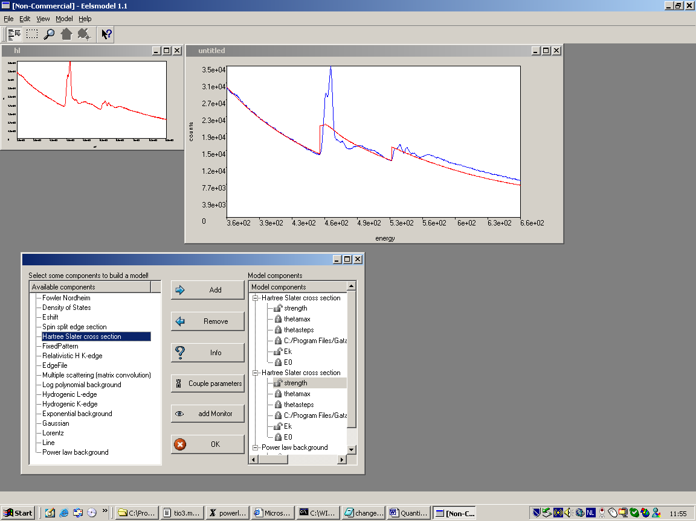
Note: to improve the readability of the model, you can change the names of the components to "O K" and "Ti L23" by left clicking on the component name, filling in the name and pressing the [enter] key (pressing the left mouse key will discard the changes)

Update the strength of the O K-edge to better fit the experiment.

Add multiple scattering
Now add a multiple scattering component. The component will ask to click the low loss spectrum.
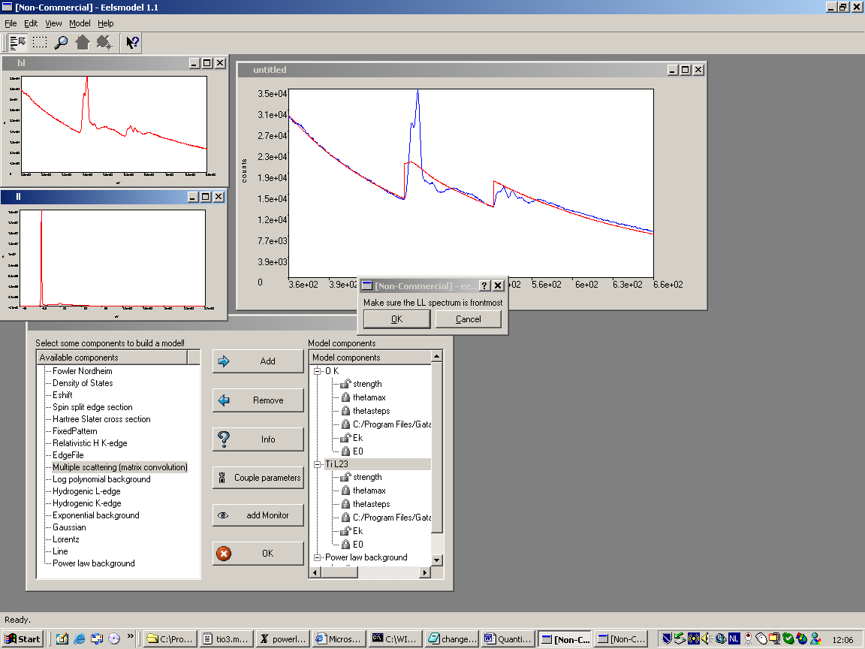
We note the distinct change in the model after applying multiple scattering. This is maybe the most important in creating a realistic model.
Note: it doesn't matter when you enter the multiple scattering component, any component that you add later will still be convoluted by the multiple scattering component.

Adding fine structure
The real spectrum clearly contains a detailed fine structure which is not included in our current model. We solve this by adding a [density of states] component for both O K-edge and Ti L23-edge.
Add the density of states component with the following parameters:
for O K-edge:
- 60 datapoints (this will give about one point per eV which is approximately the resolution of the experiment-this depends the Estart and Estop parameters but can not be altered later!)
- Estart=531 [eV] (choose this equal to the edge onset of the hartree slater, and lock the Ek parameter of the HS edge by left clicking on the lock icon of the parameter!)
- Estop=590 [eV] (estimate till how far the fine structure extends)
for Ti L23-edge:
- 70 datapoints
- Estart=455 [eV] (lock Ek of HS Ti L-edge!)
- Estop=515 [eV]
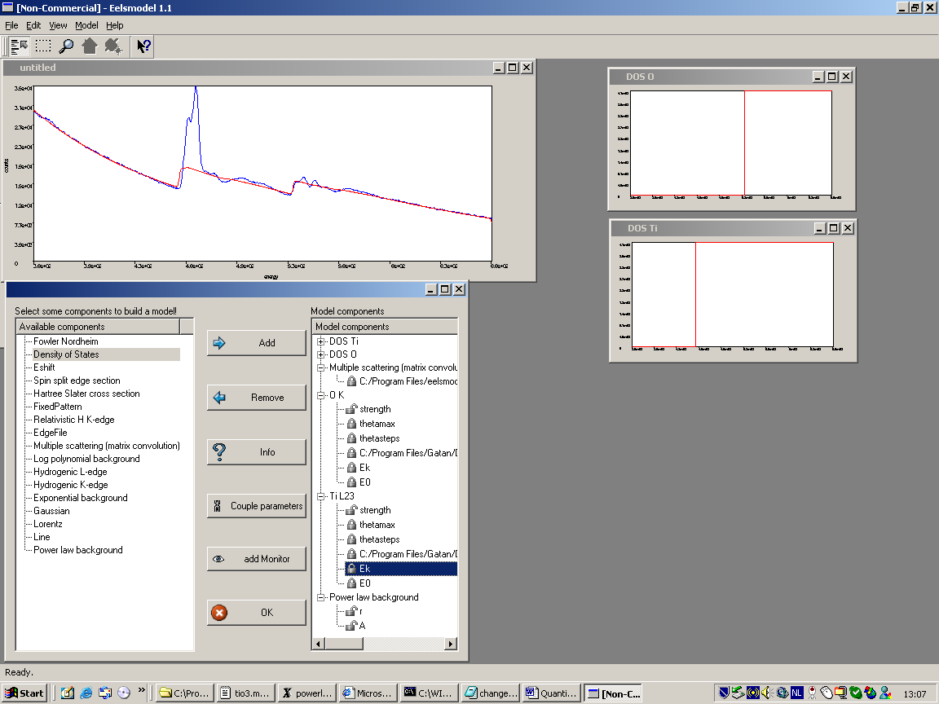
note: that the DOS is displayed separately in two windows. At initialisation the DOS is still featureless.

Fitting the model
Now we are ready to fit the model to estimate the parameters of the model. Select a fitter in [model] [fit]. Choose the maximum likelihood for Poisson statistics.
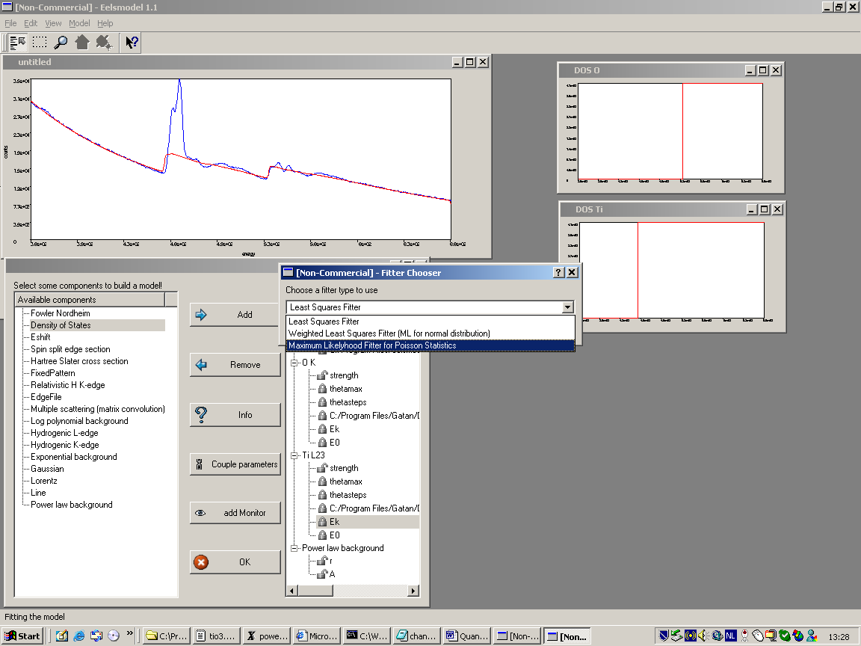
which will bring up the [fitter options] window.
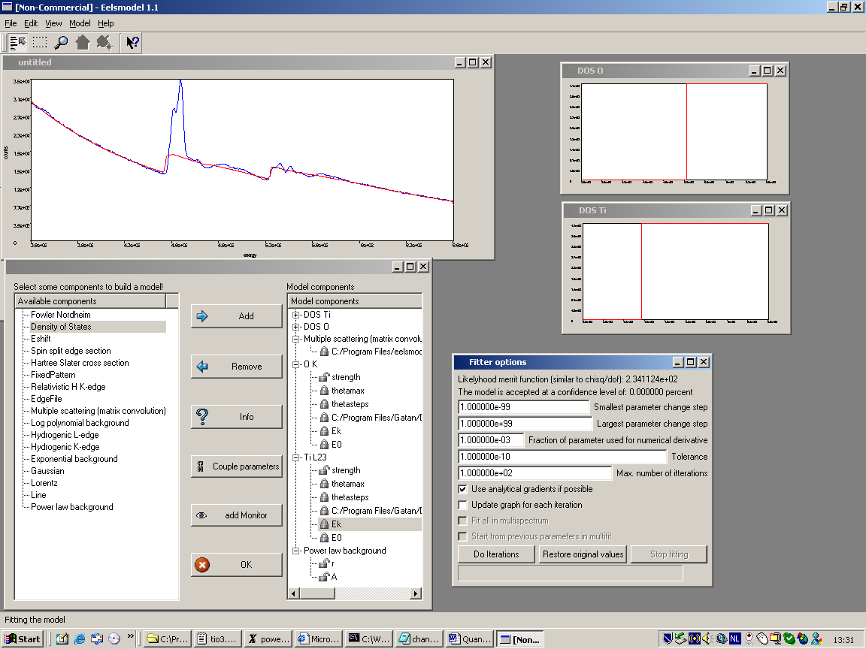
The fitter options window allows to set up the parameters of the fitting process:
- smallest parameter change step: usually no need to change this
- largest parameter change step: usually no need to change this
- fraction of parameter used for numerical derivative: this parameter determines the step used for numerical derivatives as a fraction of the value of the parameter. For parameters close to zero, it may be better to raise the smallest parameter change step to something like 1e-3. Usually you don't need to change this.
- tolerance: if the value of the likelihood merrit function changes less than tolerance for two iterations in a row than the model is assumed to be converged. We set it e.g to 1e-5. Setting it higher will stop the fitter earlier but maybe we didn't reach the true minimum yet.
- max number of iterations: the fitter will automatically stop after this amount of steps. You can restart the fitter with [do iterations]
- the radio button use analytical gradients if possible: this greatly speeds up the calculations, components can have an analytical expression for their derivative wrt. to one of the parameters. Unclick this if you suspect that a certain analytical derivative is wrong. Usually always check this button.
- update graph each iteration: this can help to see what the fitter is doing. This will make the fitting process a lot slower. Usually don't use this to increase performance.
Start the fitting with [do iterations]. You can cancel it with [stop fitting] if it is taking to long or when the likelihood merit function is not dropping.
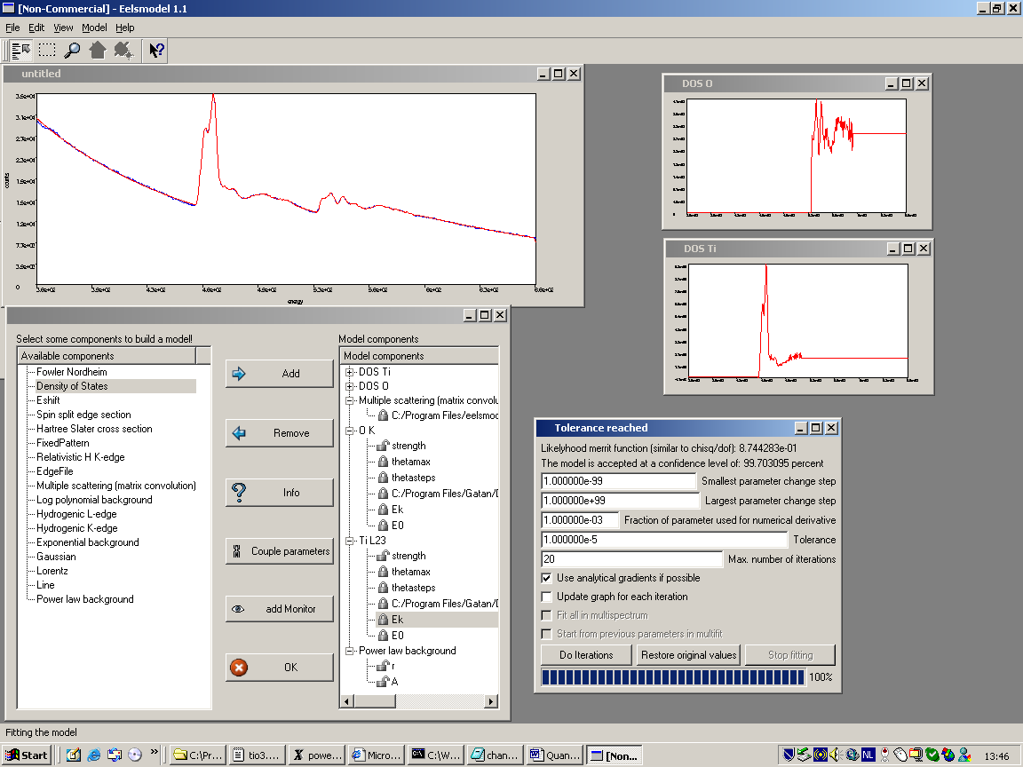
Note: in this case it is important to exclude some points from the fit. At the end of the spectrum there is an artifact in the model caused by the multiple scattering. For a description on the nature of this artifact see [1]. In the beginning of the spectrum there is some fine structure modulation from a small carbon contamination peak. We don't want to fit carbon, so we exclude this region also.
To exlude a region choose the region select tool and select a region on the spectrum. The go to [edit] [exclude points]. The excluded points will get a darker color. You can undo this by [reset exclude points] for a region (when a region is selected) of for the whole spectrum (when no region is selected).
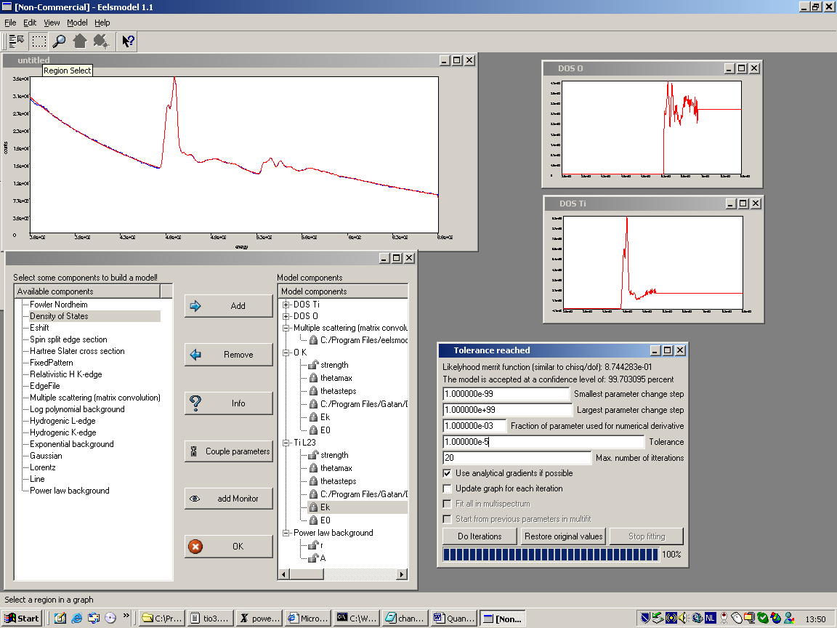
after fitting again, we see that this severely improves the fit
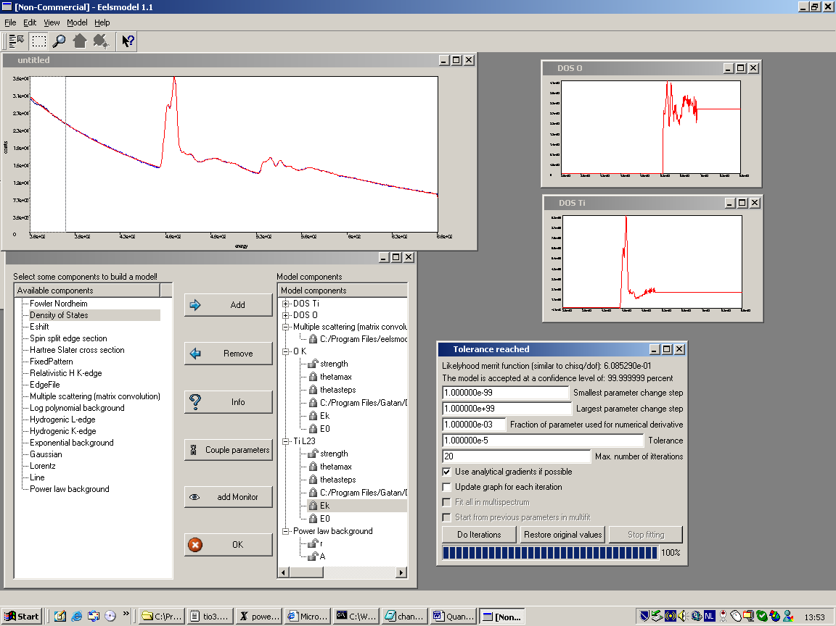
We check whether the model is acceptable by reading "the model is accepted at a confidence level of 99.99%". For any good model this should be at least 5%. For more info on the theory behind this value read [1].
Note also that the density of states windows are updated now.

Obtaining the O/Ti ratio
To obtain the O/Ti ratio we install a monitor. Click on the O K strength parameter then click on [add monitor] and then click on the Ti L23 strength parameter.
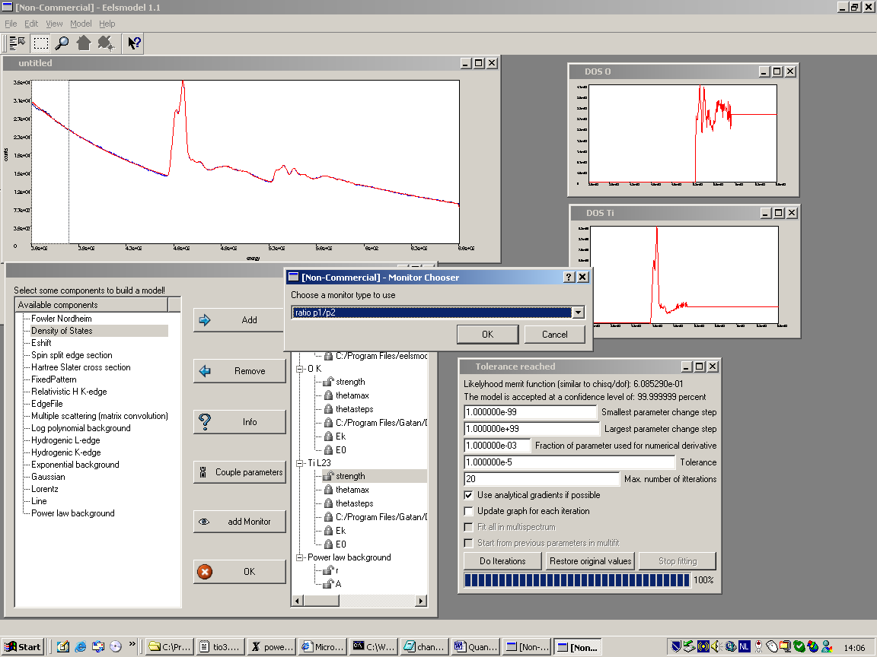
Choose a ratio monitor.
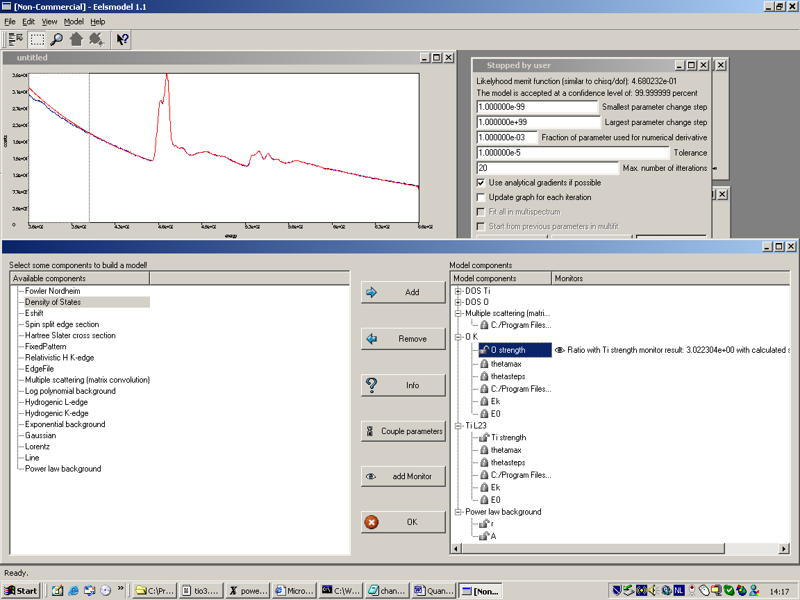
The monitor now appears as a second column in the model component list.
Note: Calculating a ratio between 2 parameters like this is important because in this case the calculated precision takes into account the correlation between the two parameters. This is something you can not do outside the program because the correlation matrix is not exported.

We obtain a final result
O/Ti=3.0224+-0.0412

Note: This result may depend on the details of the model. How many points you excluded etc. The fact that the model is statistically accepted does not mean you get the absolute correct value, but only means you get a certain precision if you would repeat the same experiment (really measure a new spectrum with different noise). There are no guarantees that there are no systematical errors although usually the result is remarkably close to the true value. Anyway it is recommended to check this with reference spectra.

Exporting and saving the results
After fitting it is important to be able to export and/or save the results.
First of all we save the whole project with [file][save project]. This stores the model, fitter options, exclude points, location of spectra etc and enables to retrieve the project if all files are still present.
Choose a filename with an extension .mod
Note: When exporting a model to a different computer, make sure to also copy the spectrum files. When loading the program may ask to point out where the files are when they are not found where the model expects them.
Note: a *.mod file is readable in a text editor, sometimes you can edit this file if you want to create the same model for different input files. This saves time

You can store the parameters by choosing [save report]. This saves the parameters of the model in a tab separated text file that can easily be opened eg. in Excel for further processing or making graphs.

Use [save model as txt] to store the different components as separate spectra in a tab separated text file. This can be handy to plot the different components of the model in aplotting program or in Excel. This is handy e.g. to plot the density of states components and compare them with calculated density of states.

Downloading and installing EELSMODEL
Got to the website [2] and download the windows version and store it in the program files directory (or somewhere else). Then unzip the files to this directory. A directory eelsmodel_release_1_1 will be created. The program file eelsmodel.exe can be found in the eelsmodel subdirectory. Create a link to this file on the desktop and select the
eelsmodel_1_1_icon.ico in the icons subdirectory as the icon for this link (do this by right clicking the link and setting the properties)
that's all...

If you want to change the code or add your own components than read the how_to_compile.txt file under the eelsmodel subdirectory. You will need a non-commercial version of qt together with the free borland compiler. You get both quite cheap with [3].

For Mac OS X and Linux. You can get the gcc compiler and a free non commercial version of qt, which should enable you to compile. (probably for advanced users - if you succeed consider sharing it with others by sending a compiled version to me, together with detailed info)

References
[1] J. Verbeeck, S. Van Aert, Model based quantification of electron energy loss spectra, Ultramicroscopy 101 (2004) 207-224
[2] http://webhost.ua.ac.be/eelsmod/eelsmodel.htm
[3] "C++ Gui Programming With Qt 3 (Bruce Peren's Open Source)" by Jasmin Blanchette and Mark Summerfield

